2019 Participant Application
Page1

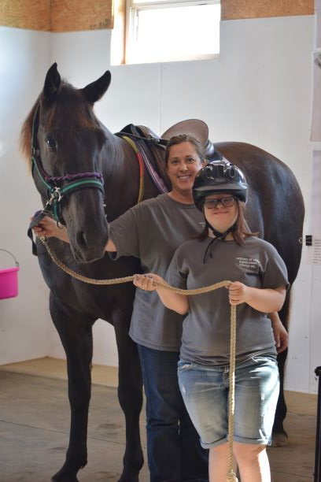

“Providing Hope and Happiness with Horses”

Hooves of Hope Equestrian Center Inc.
735 Chenault Bridge Road, Lancaster, KY 40444 (859)792-8938

How to Become a Participant at Hooves of Hope
Page2

[ ] Complete General Information Form
- [ ] Complete Health History
- [ ] Sign Information For Parents Form
- [ ] Complete Emergency Medical Treatment Form
- [ ] Sign Release Forms
- [ ] Sign Photo Release Form
- [ ] Doctor Complete Physician Form
- [ ] Complete Assessment Form
- [ ] Return Completed Forms to Facility

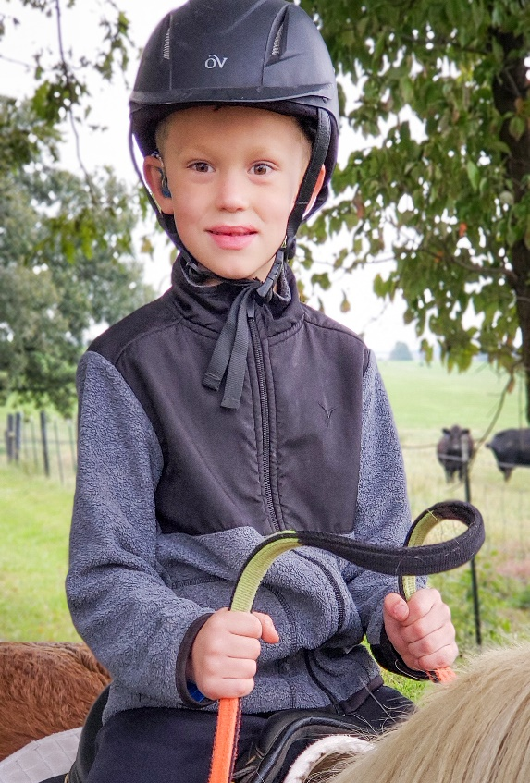
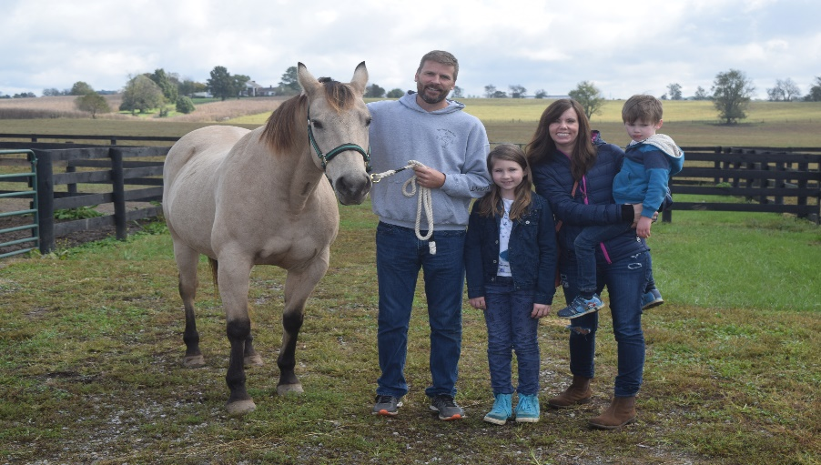
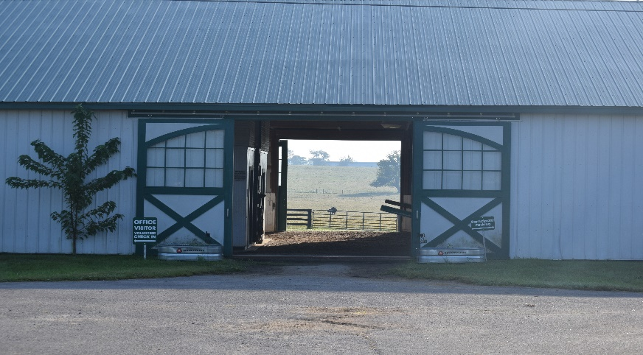
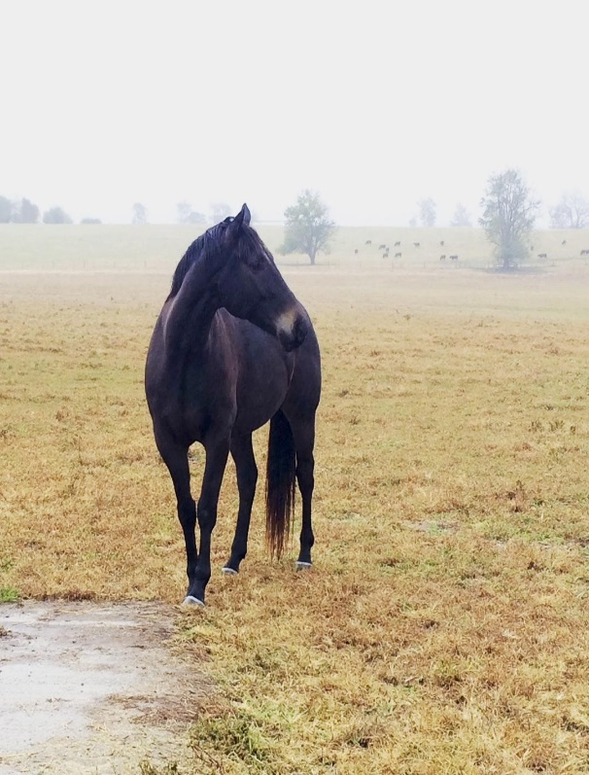

Page3

Hooves of Hope Equestrian Center Inc.
735 Chenault Bridge Road, Lancaster, KY 40444 (859)792-8938

Dear Prospective Hooves of Hope Participant,

Thank you for your interest in Hooves of Hope Equestrian Center, Inc. Enclosed you will find general information on our programs, the application process, and the required application paperwork.

The application process for therapeutic horseback riding, and equine learning programs are the same. Once all the completed forms have been received by our office, you will be contacted to schedule a pre-session assessment if you are new to Hooves of Hope. Returning participants don’t have to go through another assessment unless there has been a
significant gap in time participating in any of our programs.

Following the assessment, you will be added to our participant list and the information you provide on the enclosed forms will assist us with scheduling and determining the goals and the appropriateness of the program for an individual. Program openings are based on the availability of resources. Many of our participants return each year/semester and openings are limited. Please know that we do all that we can to integrate participants whenever possible. When an opening becomes available, you will be contacted to schedule enrollment into the program.

Should you have any questions, regarding the application process, enclosed forms, would like to arrange a visit or check on your status, please contact us at (859) 792-8938.

Sincerely,

Blair Newsome Executive Director

Page4

Application Process and Participant Policies
Application Process: Available online or upon request, Hooves of Hope provides the required forms for participants, which must be fully completed and accepted by Hooves of Hope. Each form must be signed by the appropriate party. Note our Physicians Release Form must be signed by a physician. The following forms are mandatory prior to participation:

Registration and Release/Authorization for Emergency Medical Treatment Form
- General Information and Health History Form
- Physician Release Statement

Once all forms have been received, you will be contacted for a pre-session assessment for any new participants or returning participants that have been away for a year or more. Following the assessment, the prospective participants will be placed on the Participant List.

Scheduling: Hooves of Hope offers three sessions per year: Spring, Summer, and a Fall session. Each lesson is 60 minutes in length based on the individual’s needs and scheduled availability. Lessons can be private or semi-private (groups of no more than 2). Usually, participants with similar goals are grouped together. Lessons are scheduled for the same day and time each week for the length of the session.

Payment: Hooves of Hope excepts payment to be made in full, on or before, the first lesson of each session.

Scholarships: Hooves of Hope partners with various individuals and companies to give scholarships to individuals in financial hardship. The scholarship program can only be utilized for one session a year per family. The scholarship application must be filled out two weeks before the session starts to give the scholarship committee time to review all applications. Hooves of Hope scholarships are available based on funding.

Attendance: Hooves of Hope expects consistent attendance by all participants. If you are unable to attend a regularly scheduled lesson, notification must be made by calling or texting Hooves of Hope at (859)792-8938 as soon as the absence is anticipated so we may provide enough notice to staff and volunteers. Due to our schedule and limited resources, there are no make-up opportunities for missed lessons unless Hooves of Hope cancels classes due to some unforeseen circumstance such as instructor absence or severe weather. At that time, all reasonable attempts will be made to notify participants at least two hours prior to the change.

Attire: Participants should dress weather appropriate and always wear long, non-slippery loose-fitting pants (comfortable attire) or knee length shorts (summer sessions), with sturdy soled boots or shoes that can be tied well for stability. Jackets and gloves are required for cold weather as the indoor arena is not heated.

Page5

Hooves of Hope Statement
of Participant Eligibility or Dismissal

Hooves of Hope Equestrian Center, Inc. offers services to individuals with diverse needs. Eligibility for participation in Hooves of Hope programs’ is based solely upon individual’s ability to participate meaningfully and safely, provided the necessary resources are available including: an instructor, horse, volunteers, and class availability which meets individuals’ needs. Financial consideration is not considered in determining the eligibility for participation.

As a PATH Intl. center member, Hooves of Hope fully ascribes to the Precautions and Contraindications as recommended by the Medical Committee of PATH Intl. as well as Professional Standards. Therefore, our professional staff provides initial and ongoing evaluations for all prospective and active participants.

Due to the nature of therapeutic riding and other equine assisted activities, there are individuals for whom Hooves of Hope programs are deemed inappropriate during the evaluation process and are not accepted for enrollment or are not eligible to continue in Hooves of Hopes’ programs. This determination is made based on physical, behavioral, and other limitations.

Individuals accepted into Hooves of Hopes’ programs are required to take part in periodic progress reviews and follow Hooves of Hopes’ rules and procedures. During these reviews, or as a result of unusual occurrences during a program session, the Hooves of Hope professional staff may find that continuance in the program for a given individual is inappropriate. For this reason, Hooves of Hope reserves the right to discontinue the participation of an individual in its programs when it is deemed that discontinuance is in the best interest of Hooves of Hope and/or the individual concerned.

Hooves of Hope reserves the right to decide if we are unable to serve an applicant due to unavailable resource (s) and/or safety concern including PATH Intl. guidelines relating to contraindications for participation.

Page6

Riding Participation Criteria

  - Physically able to sit symmetrically with torso upright and legs astride the horse during dynamic movements.
  - Physically able to maintain head and neck position independently in proper alignment with dynamic movement.
  - Weigh less than 180 pounds.
  - Able to sit independently without side walker support.
  - Doesn’t exhibit physical or behavioral conditions that are contraindicated by PATH Intl.
  - Have current signed and dated paperwork-including Registration and Release Form, Medical History Form, and Annual Update Form.
  - Benefit physically, emotionally, socially and/or cognitively from services provided at Hooves of Hope Equestrian Center, Inc.
  - Complete an intake assessment where trained staff evaluate eligibility.
  - Able to tolerate a riding safety helmet.
  - Ability to accommodate the movement of the horse without pain.
  - Adequate range of motion in hip(s) to sit astride.
  - Safety awareness around animals.
  - Ability to express pain and discomfort.
  - Behave in a manner that is safe for self, horses, and others.

Page7

INFORMATION FOR PARENTS (Please keep a copy for yourself)

We appreciate everyone adhering to the following so that the Hooves of Hope facility/barn remains a safe and enjoyable area for everyone:

- All children who come to Hooves of Hope are the responsibility of the adult with whom they arrive. For safety, all children who are not participating in a therapeutic riding lesson or equine assisted activity must be supervised and remain either inside the viewing area, or outside of the barn in the grassy areas, away from barn doors. CHILDREN WAITING FOR THEIR LESSON TO BEGIN MUST ALWAYS BE SUPERVISED UNTIL THE INSTRUCTOR INDICATES IT IS TIME FOR THE LESSON. We appreciate your understanding that distractive activities such as ball tossing, running and Frisbee cannot take place outside, while lessons/sessions are in lesson/session.

- No running, yelling or loud voices are permitted in the barn, unless under the instruction of a staff member during a session.

- No flash photography is permitted unless you first check with a staff member. We ask that no parents or guardians be in the arena area while a lesson/session is in progress. We ask that if you would like to take photos of your child during a lesson/session that you contact the office ahead of time.

- No smoking is permitted inside or outside the barn.

- Please call or text (859)792-8938 if you will be late for your scheduled lesson/session or need to cancel and reschedule.

- The dress code for Hooves of Hope Participants is: T-shirt or short sleeve shirt, jacket in the cool weather, knee length shorts (during the summer) or jeans and must be of non-slippery fabric and CLOSED TOE SHOES AND CLOSED HEEL SHOES that can be tied well for stability. A participant arriving with sandals or flip-flops will not be allowed to enter the arena where horses are present.

- The Hooves of Hope instructor(s) reserve the right to modify a participant’s lesson and program within the instructor’s scope of practice, in order to ensure the safety of the participant, the staff and the horses. Any modifications or plan changes will be based on the instructor’s professional judgment and may result in the withdrawal from Equine Assisted Activities with the replacement by an alternate and comparable activity. The head instructor will determine whether an appropriate horse and staff are available for each participant applying for Equine Assisted Activities. If a rider exhibits temper tantrums, frustration or agitation while in the presence of a horse, the head instructor will assist the participant to transition to an alternate Equine Assisted Activity.

I have read and understood the above and agree to adhere to the safety rules;

Parent/Guardian, Rider/Client Signature:

Witness: Date:

Hooves of Hope Equestrian Center Inc.
Participant Application and Health History

GENERAL INFORMATION

Participant:

DOB:
Age:
Height:
Weight:
Gender: F/M

Address: Phone: Email: Alternative #: Employer/School: Address: Phone: Parent/Legal Guardian/Caregivers: Address (if different from above): Phone:

I hereby consent for the above information to be maintained in the HHEC database so that I may receive information about the program.

_______________________________________________________________________________________

Signature: Parent/guardian if rider under 18

Page8

How did you hear about the program?

[ ] New Participant [ ] Returning Participant Date of Last Participation:

Goals (What would you like to accomplish from participation in the program?)

Areas of interest, games, and activities enjoyed:

Page9

HEALTH HISTORY

Diagnosis: Date of Onset: Please indicate current or past special needs in the following areas:

Vision Y N Hearing Y N Sensation Y N Communication Y N Heart Y N Breathing Y N Digestion Y N Elimination Y N Circulation Y N Emotional/Mental Health Y N Behavioral Y N Pain Y N Bone/Joint Y N Muscular Y N Thinking/Cognition Y N Allergies Y N

Medications (include prescriptions, over-the-counter; name, dose and frequency)

Describe your abilities/difficulties in the following areas (include assistance required or equipment needed):

Physical Function (i.e. Mobility skills such as transfers, walking, wheelchair use, driving/bus riding)

Psycho/Social Function (i.e. Work/school including grade completed, leisure interests, relationships-family structure, support systems, companion animals, fears/concerns, etc)

Please contact our office is you have any question.

Page10

Authorization for Emergency Medical Treatment

Name: Physician’s Name: Preferred Medical Facility: Health Insurance Company: Policy # Allergies to medication: Current Medication:

Person(s) to be contacted in case of an emergency:

- Name: Relation: Phone:

- Name: Relation: Phone:

If emergency medical treatment is required due to illness or injury during the process of receiving services, or while being on the property of HHEC. I authorize Hooves of Hope Equestrian Center, Inc. to:
  - Secure and retain medical treatment and transportation, if needed.
  - Release participants / client records upon request to the authorized individual or agency involved in the medical emergency treatment.

Consent Plan
This authorization includes x-ray, surgery, hospitalization, medication, and any treatment procedure deemed “lifesaving” by the physician. This provision will only be invoked if the person(s) listed above are unable to be reached.

Consent Signature: Date:_______________
Signature of parent/guardian if rider is under 18

Non-Consent Plan
I do not give my consent for emergency medical treatment/aid in the case of illness or injury during the process of receiving services or while being on the property of the agency.

[ ] Parent or legal guardian will remain on site at all times during equine assisted activities
Non-consent requires you to remain in the parent viewing room at Hooves of Hope while the participant is on our property.

[ ] In the event emergency treatment/aid is required, I wish the following procedures to take place:

Non-Consent Signature: Date:
Signature of parent/guardian if rider is under 18.

Hooves of Hope Equestrian Center, Inc. Liability Release for Equine Activity

(Participant's Name) would like to participate in an equine related activity at Hooves of Hope Equestrian Center Inc. I acknowledge the risks and potential for risks of riding lessons and horse related activities. However, I feel that the possible benefits to myself/my son/my daughter/my ward are greater than the risk assumed. I hereby, intending to be legally bound, for myself, my heirs and assigns, executors or administrators, waive and release forever all claims for damages against Hooves of Hope Equestrian Center, Inc. and its Employees, Instructors, Therapists, Aides, Volunteers, Equines, Equine Owners, Equipment and Operating Site for any and all injuries and/or losses I/my son/my daughter/my ward may sustain while participating at Hooves of Hope Equestrian Center, Inc.

"WARNING: Under Kentucky law, a farm animal activity sponsor, farm animal professional or other person does not have the duty to eliminate all risks of injury of participation in farm animal activities. There are inherent risks of injury that you voluntarily accept if you participate in farm animal activities.

Signature:
Signature of parent/guardian if participant is under 18
Date:

Photo Release (Please sign 1 st or 2nd option, not both)
I hereby consent to and authorize the use and reproduction by Hooves of Hope Equestrian Center, Inc. of any and all photographs and any other audiovisual material taken of me/my son/my daughter/my ward for promotional material, educational activities, exhibits, electronic publications (including the World Wide Web) or for any other use for the benefit of the program.

Photo Release Signature: Date:
Parent/guardian if participant is under 18

Do Not Photograph Signature:
Parent/guardian if participant is under 18
Date:

Page11

Page12

Physician’s Statement

Dear Physician:

Your patient, (participant’s name) is interested in
participating in supervised equestrian activities.

In order to safely provide this service, our center requests that you complete/update the attached Medical History and Physician Statement Form. Please note that the following conditions may suggest precautions and contraindications to Equine Assisted Activities. Therefore, when completing this form, please note whether these conditions are present, and to what degree.

Participant: DOB: Height: Weight: Diagnosis: Date of Onset: Past/Prospective Surgeries: Date of last seizure: Seizure Type: Controlled? Yes No:

Please List If Applicable

Medications: Medical Devices: Allergies:

Does this participant have:
Circle one:
Asthma | Yes or No
EpiPen | Yes or No
Inhaler | Yes or No

Does this participant use:
Circle one:
Walker | Yes or No
Crutches | Yes or No
Wheelchair | Yes or No
Any Type of Body Brace such as leg brace | Yes or No

Medical History and Physician Statement Form
Orthopedic:

Spinal Fusion: Y N Atlantoaxial Instabilities: Y N Kyphosis: Y N Osteoporosis: Y N Coxas Arthrosis: Y N Cranial Deficits: Y N
Spinal Instabilities/Abnormalities: Y N Scoliosis: Y N Lordosis: Y N Pathologic Fractures: Y N Osteogenesis Imperfecta: Y N Spinal Orthoses: Y N

Internal Spinal Stabilization Devices: Y N

Neurological:
Hydrocephalus/shunt: Y N Tethered Cord: Y N Hydromyelia: Y N

Spina Bifida: Y N Chiari II Malformation: Y N Paralysis due to Spinal Cord Injury: Y N

Seizure Disorders: Y N

Medical/Surgical:
Allergies: Y N Poor Endurance: Y N Diabetes: Y N Hip/Joint Subluxation and Dislocation: Y N Hemophilia: Y N Serious Heart Condition: Y N

Recent Surgery: Y N Cancer: Y N Peripheral Vascular Disease: Y N Varicose Veins: Y N Hypertension: Y N Stroke (Cerebrovascular Accident): Y N

Heterotopic Ossification: Y N

Secondary Concerns:
Behavior problems: Y N Thought control disorder: Y N

Weight control disorder: Y N Acute exacerbation of chronic disorder: Y N

Indwelling catheter: Y N
Page13

To my knowledge, there is no reason why this person cannot participate in supervised Equine Assisted
Activities or Therapy. However, I understand that Hooves of Hope will weigh the medical information
above against the existing precautions and contraindications.

** FOR PERSONS WITH DOWN SYNDROME:
Neurologic symptoms of Atlanto Axial Instability: Present Not Present
Name/Title: MD DO Other: Signature: Date: Address: Phone: License/UPIN Number:

Physician’s Release:
Signature: Date: Physician’s Printed Name: Address/City/Zip:

